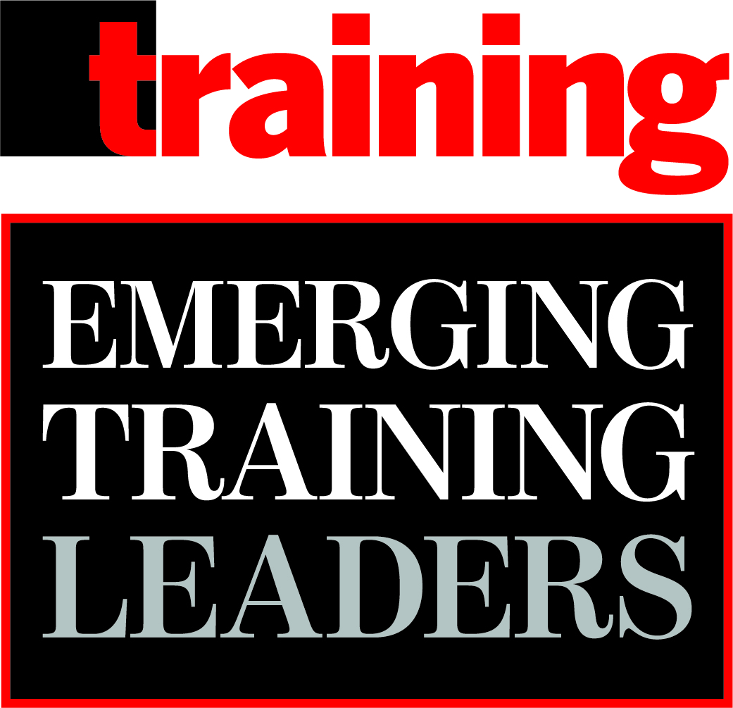
2026 Emerging Training Leaders Awards
Deadline for nominations:
June 15, 2026

Training magazine is pleased to offer the 2026 Emerging Training Leaders (ETL) awards program. The Emerging Training Leaders awards program aims to recognize training professionals who are relatively new to the training/learning and development industry (minimum of two years and maximum of 10 years in the field) and who have demonstrated exceptional leadership skills, business savvy, and training instincts.

Criteria for the Emerging Training Leaders awards nominations include:
- No self-nominations; nominations must come from managers, co-workers, peers/colleagues, clients—each company can nominate ONLY 2 candidates (there is no fee to nominate someone)
- Candidate must be in the training/L&D industry for a minimum of two years but no more than 10 years
- Candidate took on at least one new responsibility in the last year
- Candidate successfully led a large-scale training/learning and development initiative within the last year that required management/leadership of a group of people and resulted in the achievement of a business goal
- Candidate demonstrates specific leadership and business acumen skills
- Candidate has the potential to lead the Training or Learning & Development function at an organization in the next one to 10 years

Each nomination can achieve a maximum of 45 points as follows:
- Number and scope of new and current responsibilities and their importance to the business (6 points)
- Training initiative (20 points total):
Level of potential business impact (i.e., revenue generation, new product launch, change initiative, new technology launch): 0-3 points
Level of difficulty of challenges faced: 0-2 points
Project scope (companywide, individual functions, global vs. national, etc.): 0-3 points
Business unit goal the program aimed to help achieve: 0-2 points
Instructional design (learning objectives linked to business outcomes; level of leadership involved in design, development, and facilitation; reinforcement): 0-3 points
Innovation of the training: 0-3 points
Business outcomes achieved/expectations met: 0-4 points
- Leadership/business skills utilized (up to 1 point for quality of each example; plus 3 points for Level 3 and 4 results for each section for a total of 14 points)
- Readiness to lead the Training or Learning and Development function (2 points for timing; 3 points for reason(s); for a total of 5 points)

Training’s Hall of Fame organizations and other Editorial Advisory Board members and I will judge the nominations in July and August 2026. Winners and their nominators will be notified in September 2026. Winners will be featured in the March 2027 print issue of Training magazine. By submitting a nomination for the Emerging Training Leaders awards program, you give Training magazine permission to publish any information not marked NFP (Not For Publication) in a profile of the nominee that would appear in the March 2027 issue. An awards ceremony will be held February 23, 2027, during the Training 2027 Conference & Expo in Orlando, FL.

Please e-mail this nomination form to me at: lorri@trainingmag.com by June 15, 2026. ENTRIES WILL BE JUDGED SOLELY ON THE NOMINATION FORM; PLEASE DO NOT SEND SUPPORTING MATERIALS. Please e-mail me with any questions; I look forward to receiving your nomination.

Best regards,
Lorri Freifeld, Editor/Publisher, Training magazine (lorri@trainingmag.com/516.524.3504)

2026 EMERGING TRAINING LEADERS AWARDS

NOMINEE Name:

Title:

Company:
Phone:
E-mail:

Office Mailing Address (to receive award/copies of magazine):

Number of years in training (minimum of 2; maximum of 10):

NOMINATOR Name:

Title:

Company:
Phone:
E-mail:

1. Please list the new responsibilities the nominee took on in the last year and explain their importance to the organization:

2. Please describe the scope of the nominee’s current role (i.e., what they do and how many people they lead/manage/support across how many functions and geographies):

3. Please describe a training initiative the nominee successfully led in the last calendar or fiscal year utilizing their expertise and leadership skills as follows (total word limit for this section: 1,000 words):

Initiative:

Number of learners trained:

Scope of training (global, companywide, across lines of business, single department, etc.):

Measurable, numerical, specific business unit (not L&D) goal to be achieved by the training:

Level of potential business impact (i.e., revenue generation, new product launch, change initiative, new technology launch):

Challenges faced by the training team:

Details of the training:

Learning objectives:

Content development:

Level of leadership involved (meaning did the candidate work with C-suite leaders or business unit leaders, etc.) in the training design, development, and/or facilitation:

Delivery method:

Duration from creation to implementation:

Reinforcement of the training after completion:

What makes this training innovative:

Business outcomes achieved/expectations met; these specific, numeric Level 3 (behavior change as verified by a third party—NOT self-reported) OR Level 4 (business outcomes) results must show training effectively helped achieve the specified business goal listed above—for example, resulted in a 20 percent increase in sales or a 5 percent increase in productivity or a 3 percent jump in customer satisfaction scores or a 2 percent decrease in turnover:

4. Please indicate whether the nominee demonstrates high levels of leadership skills when needed or appropriate for each of the following categories AND provide an example that demonstrates they used such skills effectively in the last calendar or fiscal year (an example MUST be provided to obtain the full point for each). (Word limit for each example: 200 words):

Yes No

A. Acts as a mentor/coach
and gives regular feedback:

Provide example:

B. Collaborates and
builds successful teams:

Provide example:

C. Empowers employees:

Provide example:

D. Fosters career development
of and recognition for
direct reports/colleagues:

Provide example:

5. Please provide specific numerical Level 3 (behavior change) or Level 4 (business impact) results that demonstrate the effectiveness of the nominee’s leadership skills listed above (i.e., 3 direct reports or people managed were promoted in 2025, or 7 direct reports or people managed took on increased responsibilities, or the productivity of direct reports or people managed increased 10 percent, etc.). NOTE: These results must be different from those detailed in the Outstanding Training Initiative or in Q7 in order to earn points. (Word limit: 200 words):
Level 3 OR 4 results:

6. Please indicate whether the nominee demonstrates high levels of business acumen when needed or appropriate for each of the following categories AND provide an example that demonstrates they have used such skills effectively in the last calendar or fiscal year (an example MUST be provided to obtain the full point for each). (Word limit for each example: 200 words):

Yes No

A. Embraces and adapts
to change:

Provide example:

B. Adopts new technology:
Provide example:

C. Innovates:

Provide example:

D. Thinks strategically:

Provide example:

7. Please provide specific numerical Level 3 (behavior change) OR Level 4 (business impact) results that demonstrate the effectiveness of the nominee’s business acumen skills listed above (i.e., sales increased 27 percent after a new sales training, training costs were reduced 5 percent after converting a classroom training to microlearning, employee engagement numbers increased 20 percent after implementing mobile training, etc.). NOTE: These results must be different from those detailed in Q5 or in the Outstanding Training Initiative in order to earn points. (Word limit: 200 words):
Level 3 OR 4 results:

8. In how many years do you see this nominee leading the Training or Learning & Development function in your or another organization?
1 to 3 years
4 to 6 years

7 to 10 years
More than 10 years

Never

9. Why do you see this nominee leading the Training or Learning & Development function in your or another organization in the future? (Word limit: 200 words)

Please e-mail this nomination form to: lorri@trainingmag.com by June 15, 2026. ENTRIES WILL BE JUDGED SOLELY ON THE NOMINATION FORM; PLEASE DO NOT SEND SUPPORTING MATERIALS.

Thank you for nominating a training professional for the
2026 Emerging Training Leaders Awards.

Timeline for the awards program process:

Judging will take place in July and August 2026. Winners and their nominators will be notified in September 2026. Winners will be featured in the March 2027 print issue of Training magazine.

An awards ceremony will be held February 23, 2027, at the Training 2027 Conference & Expo at Disney World’s Coronado Springs Resort in Orlando, FL. The winners earning the top 5 highest scores will receive a free registration to the 2027 Training Conference. The other winners will receive a discount for the conference. All nominators of 2026 winners also will receive a discount for the conference.

